**How to Find RTOG 0813 Statistics**

The script **SBRTLungAnalysis** in RayStation computes D0.035, Paddick CI, traditional CI, GI, D2cm, and V20 and compares these values to accepted guidelines based on RTOG 0813 and Beshoi and Zach’s specifications. This document demonstrates how to calculate these RTOG 0813 statistics by hand, just in case.

**PTV vol [cc]**

1. Double-click PTV in left column.
2. Note volume on the planning exam.

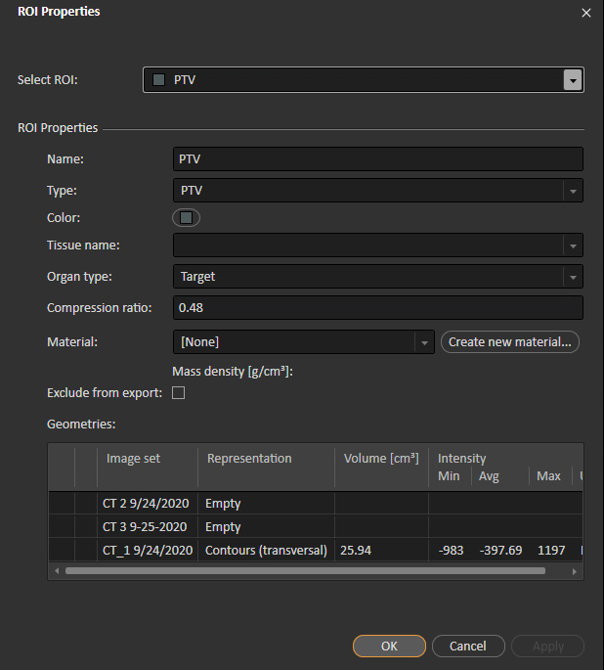

This value may differ from the value in Dose Statistics. This is a bug in RS. Do not use the value from Dose Statistics (below).

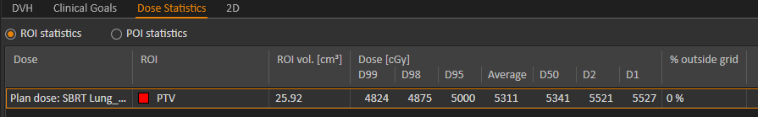

**Max dose @ appreciable volume (D0.035) [%]**

1. Plan Optimization or Plan Evaluation
2. DVH tab
3. Change dose scale to **Relative Dose [cGy]** with the Rx as the reference value.
4. Change volume scale to **Absolute**.
5. Hover over the line corresponding to ROI **External** until you see volume zero. The dose at this point approximates D0.035.

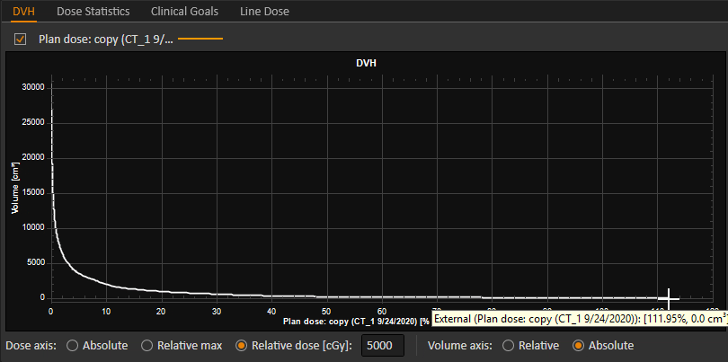

**Paddick CI**

1. Create an ROI, **100% isodose**, from the volume that receives 100% of the Rx.
   1. Plan Design or Plan Optimization
   2. Right-click image and select **Create ROI from dose…**

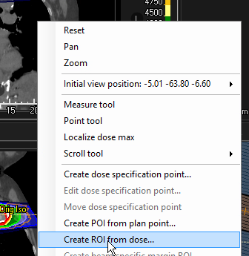

* 1. Create ROI based on 100% of Rx.

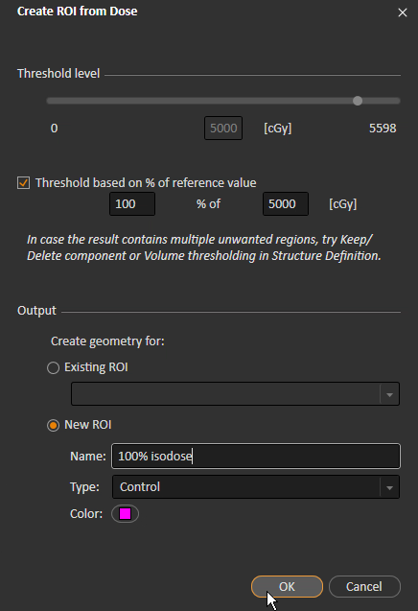

1. Create an intersection ROI, **100% isodose AND PTV**, from **100% isodose** and the PTV.
   1. Patient Modeling > Structure Definition
   2. New ROI geometry > Algebra and margins > ROI algebra…

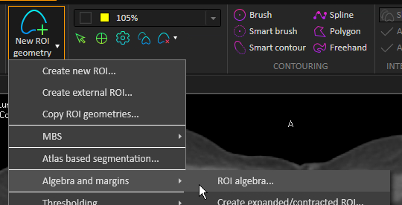

* 1. Create intersection ROI.

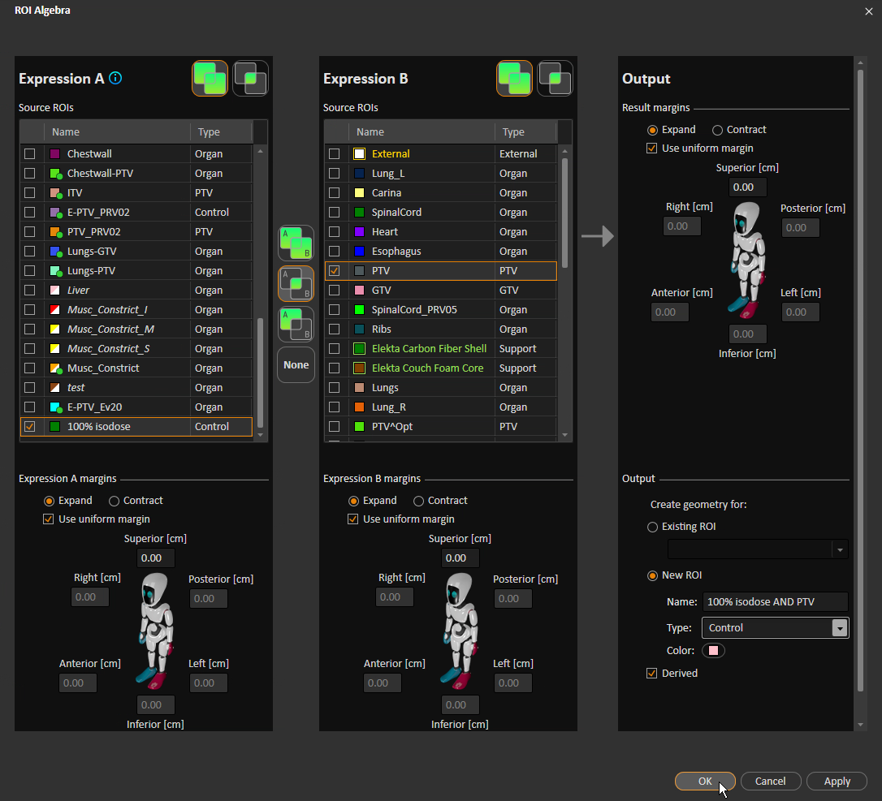

1. Compute volumes of: **100% isodose**, PTV, **100% isodose AND PTV**
   1. Double-click each ROI in left column.
   2. Note volume on the planning exam.

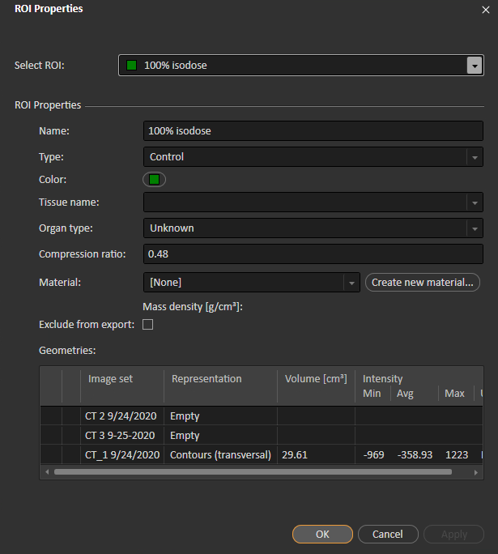

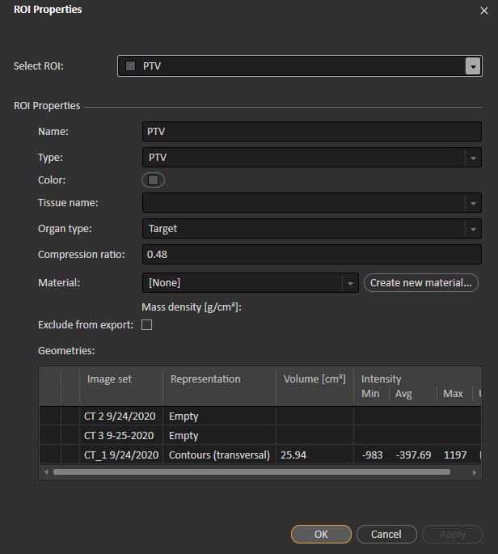

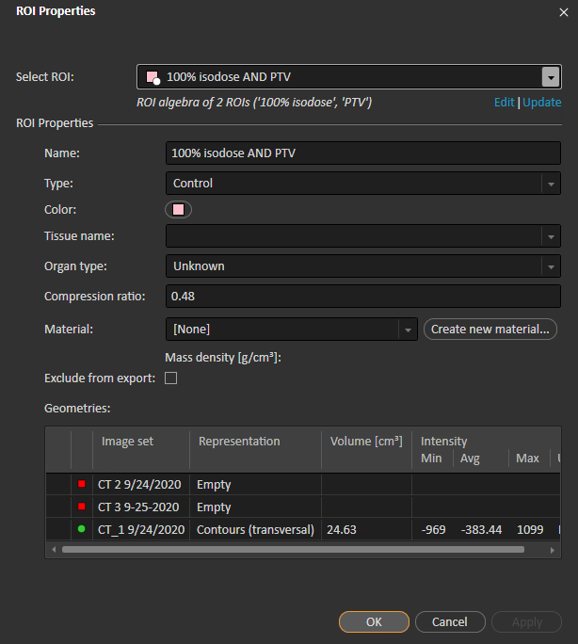

1. Paddick CI = (volume of **100% isodose AND PTV**)2 / (volume of PTV) * (volume of **100% isodose**)
   1. Example: 24.632 / (25.94 * 29.61) ≈ 0.58

**Traditional CI**

1. Create an ROI, **100% isodose**, from the volume that receives 100% of the Rx.
   1. Plan Design or Plan Optimization
   2. Right-click image and select **Create ROI from dose…**



* 1. Create ROI based on 100% of Rx.



1. Compute volumes of: **100% isodose**, PTV
   1. Double-click each ROI in left column.
   2. Note volume on the planning exam.





1. CI = (volume of **100% isodose**) / (volume of PTV)
   1. Example: 29.61 / 25.94 ≈ 1.14

**(Traditional) GI**

1. Create an ROI, **50% isodose**, from the volume that receives 50% of the Rx.
   1. Plan Design or Plan Optimization
   2. Right-click image and select **Create ROI from dose…**



* 1. Create ROI based on 50% of Rx.

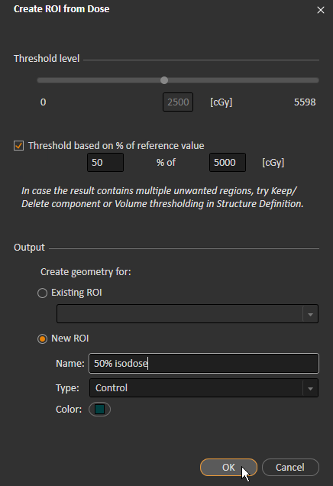

1. Compute volumes of: **50% isodose**, PTV
   1. Double-click each ROI in left column.
   2. Note volume on planning exam.



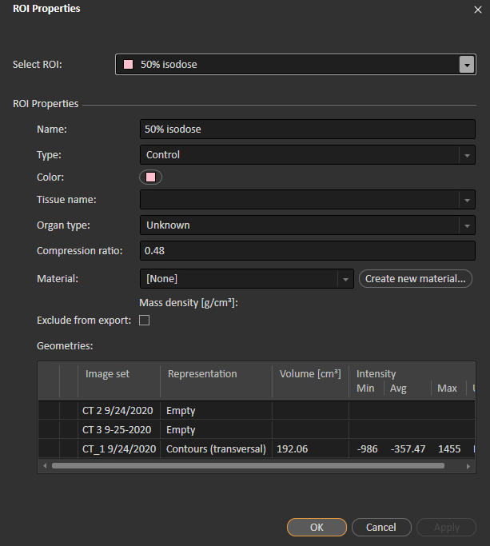

1. CI = (volume of **50% isodose**) / (volume of PTV)
   1. Example: 192.06 / 25.94 ≈ 7.40

**D2cm [%]**

1. Create ROI **E-PTV_Ev20**, if necessary.
   1. Patient Modeling > Structure Definition
   2. New ROI geometry > Algebra and margins > ROI algebra…



* 1. Create derived ROI: External minus 2cm expansion of PTV.

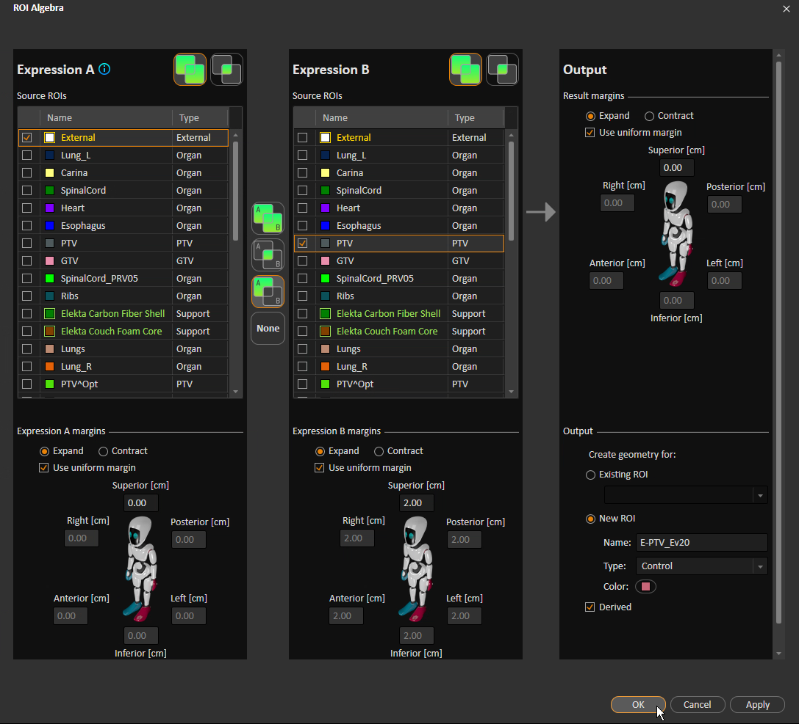

1. Plan Optimization or Plan Evaluation
2. DVH tab
3. Change dose scale to **Relative Dose [cGy]** with the Rx as the reference value.
4. Change volume scale to **Absolute**.
5. Hover over the line corresponding to ROI **E-PTV_Ev20** until you see volume zero. The dose at this point approximates D2cm.

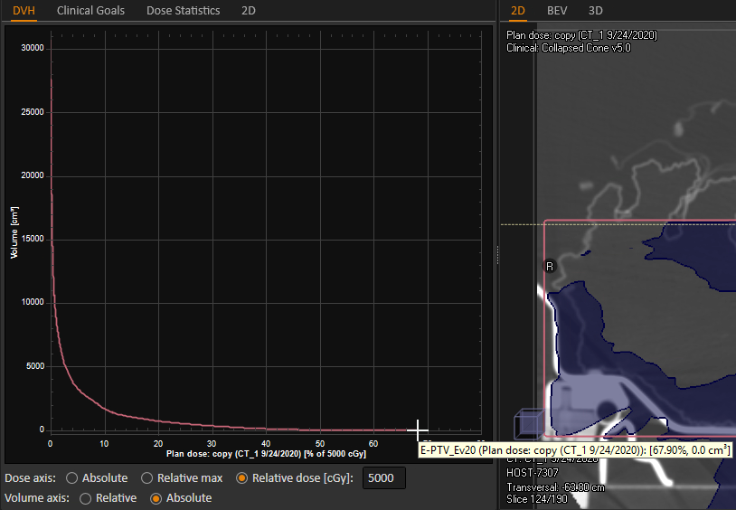

**V20 [%]**

1. Plan Optimization or Plan Evaluation
2. DVH tab
3. Change dose scale to **Absolute**.
4. Change volume scale to **Relative**.
5. Hover over the line corresponding to ROI **Lungs** until you see volume ~2000. The dose at this point approximates V20.

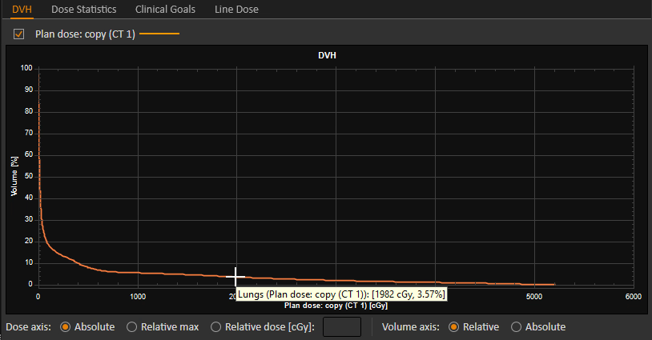

After computing the statistics, compare them to the accepted values. Deviation from accepted values is classed as none, minor, or major. RTOG 0813 specifies the following accepted values. Use the PTV volume and “eyeballed” linear interpolation to judge the approximate cutoffs for none and minor deviation.



(GI)

(CI)

Beshoi and Zach specify the following accepted values:

|  |  |  |  |
| --- | --- | --- | --- |
| **Statistic** | **None** | **Minor** | **Major** |
| Paddick CI | 1–1.2 | <1 or >1.2–1.5 | >1.5 |
| Traditional CI | 1–1.2 | <1 or >1.2–1.5 | >1.5 |
| D0.035 | 23–30 | <23 or >30–35 | >35 |